
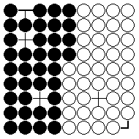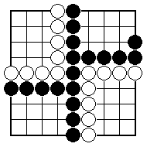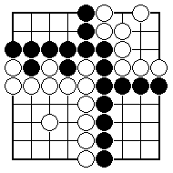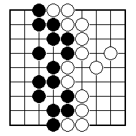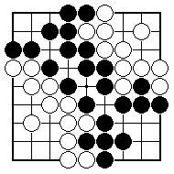
If no stones have been captured, what is the score?

If no stones have been captured, what is the score?
If no stones have been captured, what is the score?

If no stones have been captured, what is the score?

If no stones have been captured, what is the score?

If no stones have been captured, what is the score?

NAME:
BRITISH GO ASSOCIATION CERTIFICATE LEVEL 1 - SHEET 6

COUNTING THE SCORE

